Identification of an Unknown – “B”
Sarah Comer
November 30, 2023
CHEM 2081-004

- Introduction
The interpretation of data using nuclear magnetic resonance (NMR), gas chromatography/mass spectroscopy (GC/MS), and Fourier-transform infrared spectroscopy (FTIR) all work towards the goal of identifying an unknown organic compound. After blasting the compound into fragments or by exposing them to infrared or radio waves, the compound’s response is examined and documented using graphs. The motivation behind identifying organic compounds can stem from many things, but medicine and drug research is the most vital ones. For example, cocaine is an efficient drug when used as an anesthetic in surgery but has the downside of being extremely toxic. To create an analog of cocaine with lower toxicity, chemists needed to understand the mechanism of cocaine’s toxicity. Their research led to the successful creation of drugs like novocaine and benzocaine.
A daily example of how NMR, GC/MS, and FTIR are used by pharmaceutical companies is the synthesis of drugs such as aspirin. Even though the synthesis is well established, it is still important for chemists to be able to check the product’s purity by testing a sample using these methods of identification. Being able to break down an organic compound in helps reveal its entire structure and can help chemists validate their experiments.
  - Fourier-Transformed Infrared Spectroscopy (FTIR Spectroscopy)
FTIR spectroscopy is based on the concept of vibrational excitement in the bonds of a molecule. The bonds can stretch symmetrically or asymmetrically, twist, waggle, scissor, and rock. FTIR spectroscopy is unable to identify a single atom since its lack of bonds means it has zero degrees of freedom for rotation and/or vibration. The technique is based on electromagnetic radiation where the photons of light are observed as waves of energy, and the wavelengths and frequencies are the data observed. Electrons in covalent bonds contain vibrational energy levels which are separated by gaps. If a photon strikes the molecule with the exact amount of energy needed to excite the molecule, the light is absorbed, and vibrational excitement occurs. FTIR allows scientists to observe how different types of bonds absorb different infrared energies that may then be released as heat.
FTIR spectroscopy is used to identify functional groups of a molecule. A strength of FTIR spectroscopy is its ability to identify the functional groups correctly and completely, but FTIR cannot determine the number of these functional groups. The data is collected by using the difference in energy (energy gap) of the vibrational states depends that are dependent on the nature of the molecule’s bonds. As an example, the difference in energy of a C-H bond is much larger than the energy gap for a O-H bond. Both the C-H bond and the O-H bond will absorb infrared radiation when exposed, but the C-H bond will absorb a higher energy photon because of the larger energy gap. Because different bonds absorb different frequency photons, it is possible to determine which types of bonds are present in a compound by observing which frequencies are absorbed.
By observing data that shows a frequency is not detected, it may be inferred that a bond is absorbing that frequency, confirming the presence of a functional group. A plot is created using this data, displaying the frequencies that are absorbed by the sample. FTIR spectroscopy is commonly used to tell the difference between two similar compounds. It is particularly helpful when determining if the transformation of one functional group into a different functional group was successful by observing if the original functional group is absent and if the expected functional group is present.
  - Chromatography/Mass Spectroscopy (GC/MS)
Mass spectroscopy or mass spec is the method of fragmenting molecules and then determining the masses of the fragments. The collected data provides the information to determine the molar mass and formula of a compound. First, the compound is vaporized and ionized, causing it to undergo fragmentation, where one electron is removed, and the cation is measured. Then, the masses of the ions are measured and graphed. Initially, the molecule is exposed to electron impact where the sample is bombarded with high energy electrons at 1600 kcal. The high energy impact causes an electron to be ejected, and the radical cation is left behind. This radical cation remains intact and is called the parent ion or M+*. The radical then chooses one of the carbons in the molecule to latch onto, creating a radical and a carbocation. The radical is unable to be detected by mass spec because it is neutrally charged, but the cation is detected by the magnetic field. The data collected from the mass spec shows a series of peaks. One of the peaks is called the base peak, which is the most abundant fragment but is not necessarily the parent ion. Peaks with a mass-charge ratio less than the parent ion peak represent fragments.
The parent ion peak is critically important in the observation of mass spec graphs because it does not easily fragment, and it is the basis of determining the components of the fragment. If one of the peaks is 15 g/mol less than the parent ion, it is labeled as M-15. This difference is seen because the fragment is missing a methyl group. The molar mass of a methyl group is 15 g/mol, explaining the M-15. The base peak is the most abundant because it contains the most stable cation possible, and since a third-degree cation is more stable than a first- or second-degree, it may give more clues to the molecule’s structure. An odd numbered parent ion peak is a clue that the molecule contains an odd number of nitrogen molecules. By observing the masses of the fragments and the parent ion together with the other clues, the data may be compiled to help better understand the organization of the unknown molecule.
  - Nuclear Magnetic Resonance (NMR)
Nuclear magnetic resonance is the best method of gaining structural information by using electromagnetic radiation. Protons and neutrons are constantly spinning, and if there is an odd number of these particles, there is a net nuclear spin. The spinning charge creates a magnetic moment along with an induced current. By observing the right-hand rule, the direction of the magnetic moment may be observed to be perpendicular to the axis of nuclear spin. Initially, there is no uniform direction, and all the protons and neutrons are spinning randomly. Nuclear magnetic resonance then aligns the randomness of the spin by applying a magnetic field to the location of the magnetic moment either in the same direction as the magnetic field (alpha) or in the opposite direction of the applied magnetic field (beta).
The beta units have an opposing spin with a higher energy spin rate, and the alpha units have a lower energy spin rate. The collection of data is obtained by switching the states of the spinning neutrons and protons by exposing them to radio waves. Photons from the radio waves are absorbed, and the energy change is detected and graphed. Nuclei that experience less applied magnetic field are said to be shielded and require less energy to change the spin. Nuclei surrounded by fewer electrons are said to be deshielded. The data is then collected as a series of peaks and valleys called a NMR spectrum, and the graph displays the number of signals, the signal location (chemical shift), signal intensity (area under signal), and the signal shape (splitting pattern/neighbors).
The number of signals represent the different kinds of proteins present in the molecule, and the neighboring peaks give insight into what proteins are close to that specific group. The area under the peak represents the number of protons giving rise to a signal. To analyze a NMR spectrum, the steps are to calculate the HDI (hydrogen deficiency index), count the number of NMR signals and integration, analyze each signal and draw fragments, and assemble the fragments.
- Data
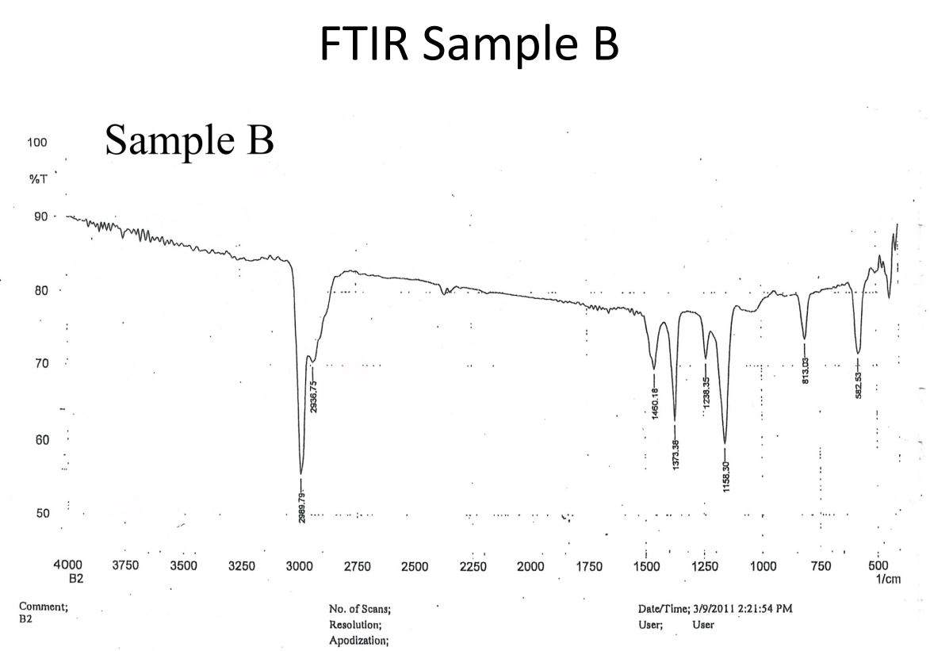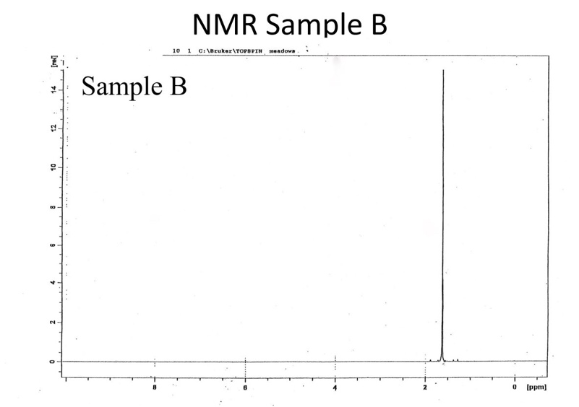
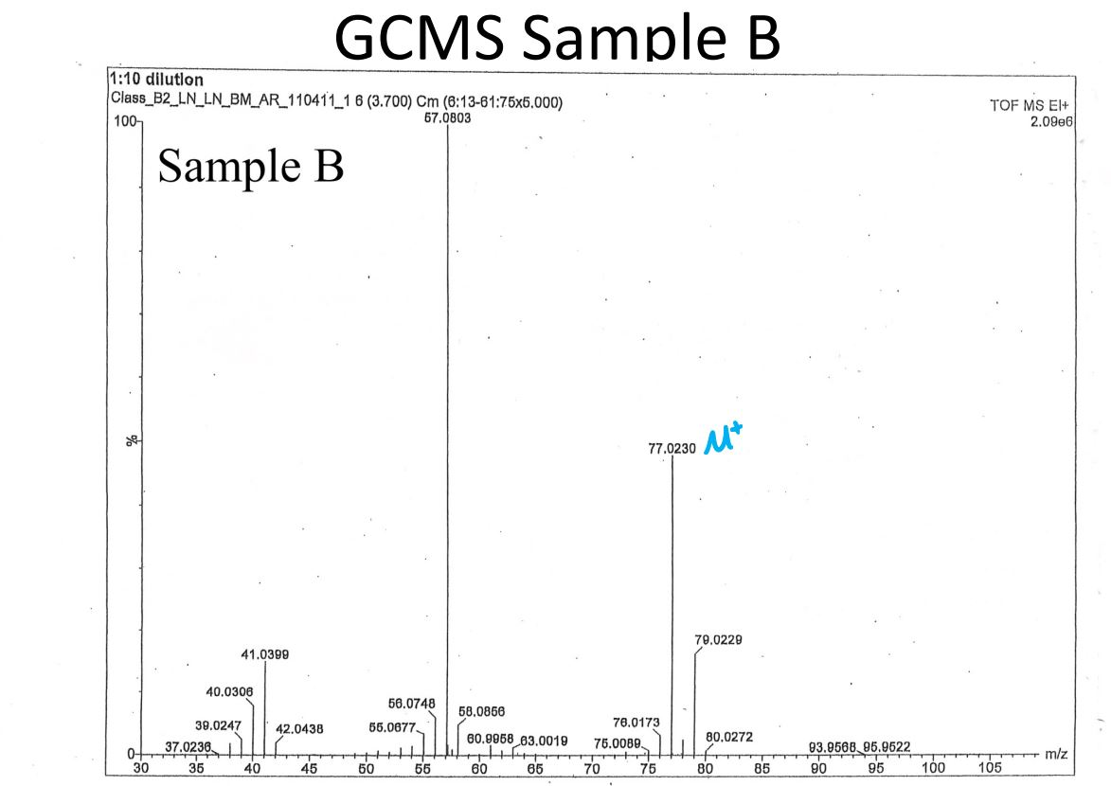

  - FTIR- Sample B
The data collected below 1500 cm⁻¹ is in the fingerprint region, which is an insufficient area to analyze for data. Instead, data must be pulled from the diagnostic region, which consists of two peaks at 2989.79 cm⁻1 and 2936.75 cm⁻¹. These two values fall just below 3000 cm⁻¹, which dictates that they are an alkyl C-H bond. They are not alkenyl or alkynyl because both of those bonds fall above the 3000 cm⁻¹ mark. The two peaks are close together, creating “teeth,” which implies bending and stretching. It is important to bear in mind that some signals are not absorbed if the molecule is symmetric, which is a major weakness of FTIR spec and should be considered if the other data forms show different functional groups.
  - GCMS- Sample B
The mass spec data has a notable outlier above the M+* at 79.0229 m/z. This outlier is roughly one third of the height of the M+* peak. This is a likely indicator that chlorine is present in this molecule because chlorine has two abundant isotopes, Cl-35 and Cl-37, which have a 3:1 ratio respectively. When the molar mass of chlorine is taken into consideration, it leaves a molar mass of 41.5703. it can be inferred that there is not another chlorine atom present because it would leave a molar mass of 6.1176 left to work with, which is less than the molar mass of a single carbon.
The base peak is at 57.0803 m/z, which is 19.9427 away from the M+* peak. Although it is not perfectly M-15, it is close enough to imply a carbocation fragment with a missing methyl group. The data sheet does not display any values lower than 30 m/z, so it may not confirm a peak at 15 m/z, which would provide more supporting evidence of a methyl group fragment. The other noticeable peak is at 41.0399 m/z, which has a difference of 35.9924 from the M+* peak. This difference matches the molar mass of chlorine, providing more supporting evidence of there being one chlorine atom in the molecule.
  - NMR- Sample B
The NMR data has a massive peak at around 1.7 ppm that indicates only the presence of methyl groups. The neighboring peaks are so small that it is very unlikely they have an area under the curve near one, so the peak may be interpreted as a singlet. This data implies that only protons belonging to methyl groups are present in the molecule.
- Conclusion
The data collected implies that the unknown molecule B is 2-chloropropane, or isopropyl chloride. The molecular formula of 2-chloropropane is C₃H₇Cl, which has a molar mass of about 78.5413, which is very close to the measured molar mass of 77.023 from the mass spec data. Isopropyl chloride also only contains methyl groups as its functional groups, which are alkyl C-H groups. This aligns with the data on the FTIR spec just below 3000 cm⁻¹. The very electronegative chlorine attached to the carbon, preventing the protons from “seeing” their neighbors, may explain the fact that no neighbors are displayed on the NMR data.
Overall, all the data provides supporting evidence that 2-chloropropane is the unknown B molecule. The FTIR spec implies the presence of an alkyl C-H stretch. The mass spec molar mass and the molar mass of 2-chloropropane are virtually similar. Finally, the NMR only suggests the presence of one hydrogen group, which is true, and no neighbors are present because the electronegativity of the chlorine atom prevents them from detecting each other.
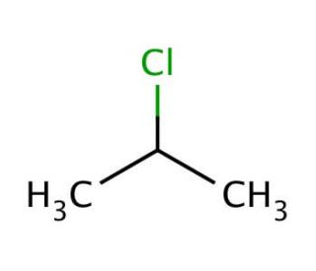
- References
Keller L, Joseph K, and Miguel S. 2023 Fall. CHEM 2081 Organic Chemistry II Lab Manual [lab manual]. Auburn (Al): Auburn University.
Klein, D. R. (2021). Organic Chemistry (Fourth ed.). John Wiley and Sons.

